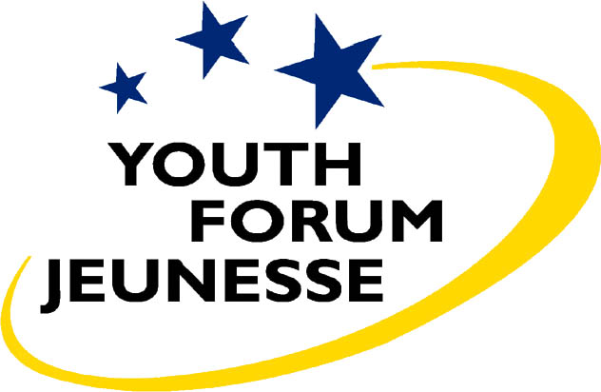


Discussion document for national debates adopted by the preparatory meeting in Brussels on January 20th, 2007

Introduction

50th Anniversary of the Treaty of Rome

In 2007, the European Union will be 50 years old. On 25 March 1957, representatives of France, Germany, Italy, Belgium, the Netherlands and Luxembourg signed the Treaty establishing the European Economic Community, along with a second Treaty establishing EURATOM, in an elaborate ceremony at the Campidoglio in Rome. In fifty years, the Community of six has grown into a Union of twenty-seven, and this will be extensively celebrated in a series of events over the course of 2007.

For youth, there is certainly also reason to celebrate the anniversary of a project that brought peace, stability and prosperity to the continent and brought opportunities that previous generations never enjoyed to the same extent. After these successful decennia, the European project seems to have lost direction and inspiration. The rejection of the Constitutional Treaty by voters in France and the Netherlands was a clear symptom of the increasing uncertainty and disenchantment of the European people with the development of the European Union.

Moreover, today in Europe, young people are facing several difficulties: increased insecurity and lack of social justice, especially concerning jobs and education, housing, and climate change. Globalisation and the effects of the global economy on our social rights and environment pose new and serious challenges, especially for the younger and future generations. Young people expect these threatening issues to be addressed by policy makers at all levels. The European Union is a crucial political level to address these issues effectively, if civil society is strengthened and fully involved in the decision-making process.

For this reason, youth delegates from all over the EU will meet at a Youth Summit, which will take place in Rome in parallel with the European Council Summit in Berlin, where they will outline their expectations of the European project for the next 50 years.

A broad, EU wide consultation

In order to develop a basis for discussion, a pre-Summit was organised in Brussels on 18—20 January, bringing together representatives from National Youth Councils in the 27 EU Member States and from international youth organisations. During three days of intensive work, the youth delegates worked on the different aspects of the
European project: the Constitutional Treaty, the European social and economic model, sustainable development, the Union’s role in the world, building a European democracy and civil society and on youth and education in the EU.

The pre-Summit resulted in this discussion document, a first basis for national debates to be organised in the different EU Member States. International youth organisations will also hold their own consultations on this document. These national debates, each involving the diversity of youth in each Member State, as well as the discussions within the broad range of international youth organisations, will be a large bottom-up consultation exercise, bringing together the views of young people from all over the European Union.

The results will be presented to the European leaders on the day of the Anniversary of the Treaty of Rome — and in the same place where the Treaty of Rome was signed — at the Youth Summit of 24—25 March 2007. However, this high visibility event should not conclude the process — it should constitute a new start of continued engagement of youth civil society in the European project. While celebrating the European integration of the last fifty years, the Youth Summit will mainly be a moment to look ahead at the challenges for the next fifty years, which will define the larger part of the lives of the young people of today.

Future of the European Treaty

- There is an urgent need for a real European constitution and for seriously involving of the European citizens in that process: either through a European referendum or a constitutional assembly. Youth Convention was held on the issue in 2002, and its conclusions are still valid for us. Some options of process have been brought up: that the new document is discussed by governments, national parliaments, constitutional assemblies or by a convention. We, the participants of the pre-summit prefer a process involving a constitutional assembly or a convention, including representatives of civil society.

- The constitution should make up a basic framework for institutions, based on the scope and structure of parts one and two in the original constitutional treaty. This would include the charter of fundamental rights, the basic values and basic rules for the institutions. Policies and detailed functioning of the union should be placed outside the constitution. That way they can be amended more easily than the constitution.

- To effectively carry out European policy-making we need to move from unanimity towards majority voting and co-decision in all competencies of the union. The European Parliament should have more power, for example the power of initiating legislation and the power to decide its own seat. The size of the European Commission is critical regarding the efficiency of the institution.

Democracy and civil society

- The current crisis in the EU that we are facing is foremost connected to the malfunction of the representative democratic bodies. Citizens around Europe don’t exercise their right to elect their representatives. Question for debate: Why are people not exercising their right to vote?

- Bearing in mind the differences throughout Europe on the concerns and possibilities of citizens we cannot deny the essential importance of being involved in Civil Society Organisations (CSO’s) in order to influence in democracy building. But still a future Europe needs to increase and diversify the participatory democratic structures. Questions for debate: What does it take for you to engage in something? How can youth-led CSO’s, in a larger extent, engage young people that are today outside the organisations and outside the debate?

- On a national level, a European dimension is needed in the political debate and this is, of course, very important as we come closer to the election for European Parliament in 2009. The communication between the EU institutions and the citizens of Europe cannot be done without engagement of the Member States. Through public funding CSO’s can also engage and take a leading role in facilitating such a debate. It is of crucial importance that we can ensure credibility and independence for CSO’s despite strong public funding through transparency. Questions for debate: How can we ensure a European dimension in the political debate on a regional and national level? What is the role of the member states regarding this? What role can CSO’s play in this? What role would the member states have in terms of recognition and funding possibilities – for building democracy and involving CSO’s?

Youth and Education

- Quality of the formal education. It is extremely important that the quality of all basic education, primary and secondary is consistently high. Subsequently, we ask for a reassessment of the content of the formal education system as it is at present, not only the transfer of knowledge as an important aspect but also the development of skills as being an integral part of the education process. This will make the education systems more rewarding for young people and could serve as a motivating factor. Education should concentrate more on how to prepare all students for their difficult transition from education to the labour market. We strongly believe that formal education should interact and be complimentary of non-formal education.

- Accessibility of formal education. Formal education has to be not only obligatory but made accessible to all. This means that each individual should have access to all educational institutions. For this to take place, barriers currently in place, whatever their nature, (whether they be financial or cultural), should be broken down and subsequently removed. Governments of all the Member States should develop and apply a governmental funding scheme supporting young people during their studies.

- The value of non-formal education should be recognised and efficiently communicated to wider society. Communication on the value of non-formal education should not remain at national level or only with actors of the youth sector but activities should developed at a local level, i.e. at schools, in the community. Furthermore, both the media and employers should be directly involved and included as partners. This can be realised only through institutional support from both the European Union and the governments of all member states. We should raise awareness among the youth themselves about the values that are gained through participation because we believe that self-awareness helps to avoid over-formalisation.

